DEPARTMENT OF COMPUTER SCIENCE & ENGINEERING
Technical talk On “ mobile application development”
09th Feb 2016
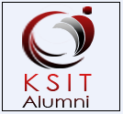

A Technical Talk on “Mobile Application Development” by Alumni UDAY, who graduated in the year 2015, Department of CSE. Technical Talk was Conducted on 09th Feb 2016 in association with KSIT ALUMNI ASSOCIATION in Department of CSE.
Number of participants: 6th Semester Students.

Seminar Details

The Inauguration of seminar started at 10:30am by introducing the Keynote speaker and his team by alumni coordinator Swathi K. After the Inauguration, the seminar on Mobile Application Development started at 10:45am by Alumni UDAY.

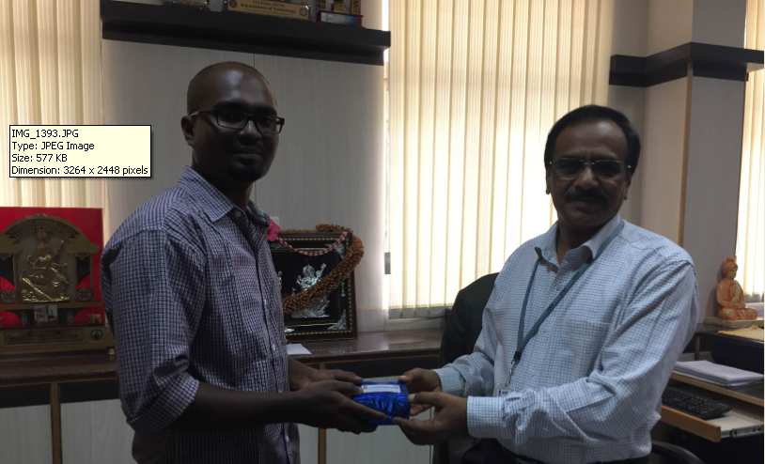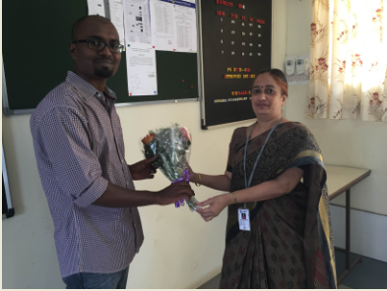
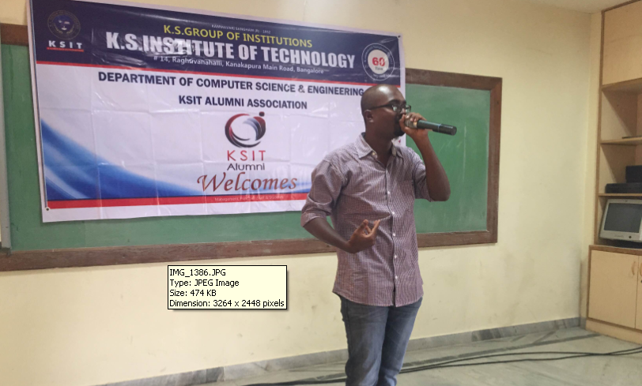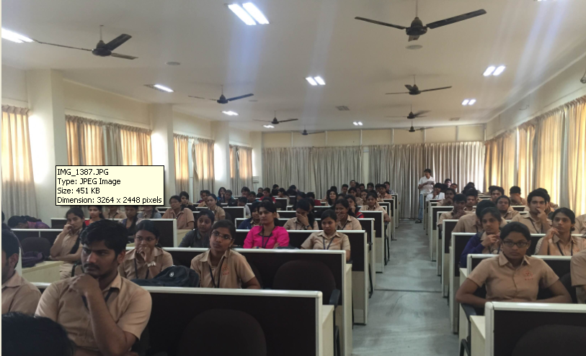

The Alumni spoke about the structure of Mobile Application Development

- Who Can do it: Students seeking for an attractive career in marketing entrepreneurs to enhance the business visibility and sales working professionals from advertising, marketing, information technology, sales, or business development who wants to specialize in Mobile Marketing.

- Different Platforms

- New Versions

- Different Types of Apps

- Quality of Apps

- How to use Open Source Course

- Scope of Mobile Development

- Training Highlights

Alumni Coordinator HOD Principal
Swathi K

